Candidate Literacy Project
Kelly’s Word Work, Sequencing and Comprehension Activities

--------------------------------------------------------------------------------------------
Final Consonants Word Work Created with Boardmaker

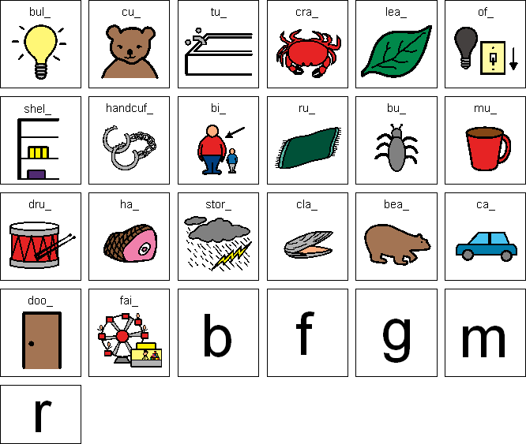

--------------------------------------------------------------------------------------------
Sequencing Activity from “The Mitten”

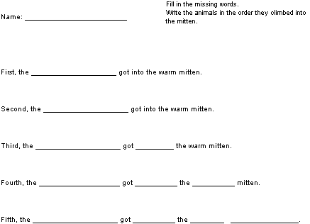

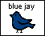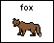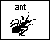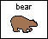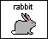
-----------------------------------------------------------------------------------
Word Work activity
Name_____________________________
Combine a blend and an ending to make a word that matches the picture. Write the word on the line below or cut and paste the words.

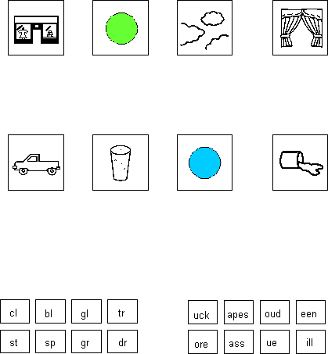
Word Work Activity
Beginning Blends Endings

